Zachary Kunz

Data Mining

11/15/2019

Katate.txt:

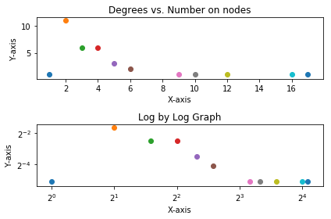

Cluster Coefficient 0.2765208311488588

HcNetwork.txt:

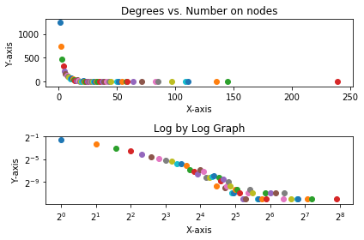

Cluster Coefficient 0.13713589712799293

HprdNetwork:

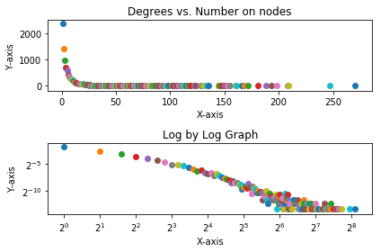

Cluster Coefficient 0.0747762234621279